Student Name: Vishal Rana

Student ID Email Address: vishalrana1305@gmail.com

GitHub Link: https://github.com/vishalrana1305/OS-project

Code:
#include<iostream>
#include<time.h>
#include<stdlib.h>
using namespace std;
int main()
{
srand(time(NULL));
int n=10,ct=0,k=0;
int pr[10],burst[10],CT[10],WT[10],burst2[10];
char pid[10]={'a','b','c','d','e','f','g','h','i','j'},pid2[10];
cout<<"All the STUDENTS or PROCESSES arrive at the same time"<<endl;
cout<<"*-------Menu-------*"<<endl;
cout<<"1. Enter the Burst time manually"<<endl;
cout<<"2. Randomly generate the Burst time"<<endl;
int ch=0;
cout<<"Enter your choice: ";
cin>>ch;
if(ch==1){
cout<<"Enter the burst time for the 10 Students or processes"<<endl;
for(int i=0; i<n; i++)
{
cout<<"Enter the burst time for "<<char(97+i)<<" : ";
cin>>burst[i];

}
}
else if(ch==2){
for(int i=0; i<n; i++)
{
burst[i]=rand()%10; // randomly generating the burst time
}
}
else{
cout<<"Wrong Choice \nProgram Terminated";
return 0;
}
cout<<"Burst Time: ";
for(int a=0; a<n; a++)
{
cout<<pid[a]<<" ";
cout<<burst[a]<<" | ";
}
cout<<endl;
cout<<"Chocolates Distribution"<<endl;
for(int a=0; a<n; a++)
{
for(int i=0; i<n; i++)
{
pr[i]=rand()%100; //Distribution of chocolates after every entry
}
for(int i=0; i<n; i++)
{
cout<<pid[i]<<" "<<pr[i]<<" | ";
}
cout<<endl;
int max=pr[0],loc=0;
for(int i=1; i<n; i++)
{
if(pr[i]>max)
{
max=pr[i]; //Finding the process or Student with maximum chocolates
loc=i;
}
}
ct=ct+burst[loc]; //completion time
CT[k]=ct;
pid2[k]=pid[loc];
burst2[k]=burst[loc];
WT[k]=ct-burst[loc];
k++;

for(int b=loc; b<n-1; b++)
{
pr[b]=pr[b+1];
burst[b]=burst[b+1];
pid[b]=pid[b+1];
}
n--;
a--;
}
cout<<"Process ID Arrival time Burst Time Completion Time Turn Around Time Waiting Time"<<endl;
for(int x=0; x<k; x++)
{
cout<<" "<<pid2[x]<<"\t|\t"<<"0"<<"\t|\t"<<burst2[x]<<"\t|\t"<<CT[x]<<"\t|\t"<<CT[x]<<"\t|\t"<<WT[x]<<endl;
}
float sum=0;
for(int p=0; p<k; p++)
{
sum=sum+CT[p]; //total turn around time
}
cout<<"Average Turn Around time : "<<(sum/k)<<endl;
sum=0;
for(int p=0; p<k; p++)
{
sum=sum+WT[p];
}
cout<<"Average waiting time : "<<(sum/k);
return 0;
}
1.Explain the problem in terms of operating system concept? (Max 200 word) Description:
- As we thoroughly go through the question, there are ten process considered to be the students as ‘a’, ‘b’, ‘c’, … ‘j’ which wants to get their pictures clicked by university camera. The students distribute the chocolates in random manner with each other and the student with highest chocolates enters the room. As one process or student gets the CPU or enters the room the game of chocolates distribution start again.
- Now, considering the chocolate distribution as the priority of the process. Where the process with highest priority or chocolates enters the room or get the CPU. As the one process get the CPU, the priority is again randomly generated and again the process with highest priority form the remaining process enters the room or gets the CPU.
- The process of chocolate distribution or randomly assigning the priority goes on until all the process have got the CPU and have completed their work.
As for the output the scheduler needs to display the calculated AVERAGE TURNAROUND TIME and AVERAGE WAITING TIME, these both calculations will be done using the following formulas:
- Turnaround time=Burst time + Waiting time
- Turnaround time=Completion time – Arrival time
- Waiting time= Turnaround time – Burst time
- Completion time= Arrival time + Turnaround time

2.Write the algorithm for proposed solution of the assigned problem. Algorithm
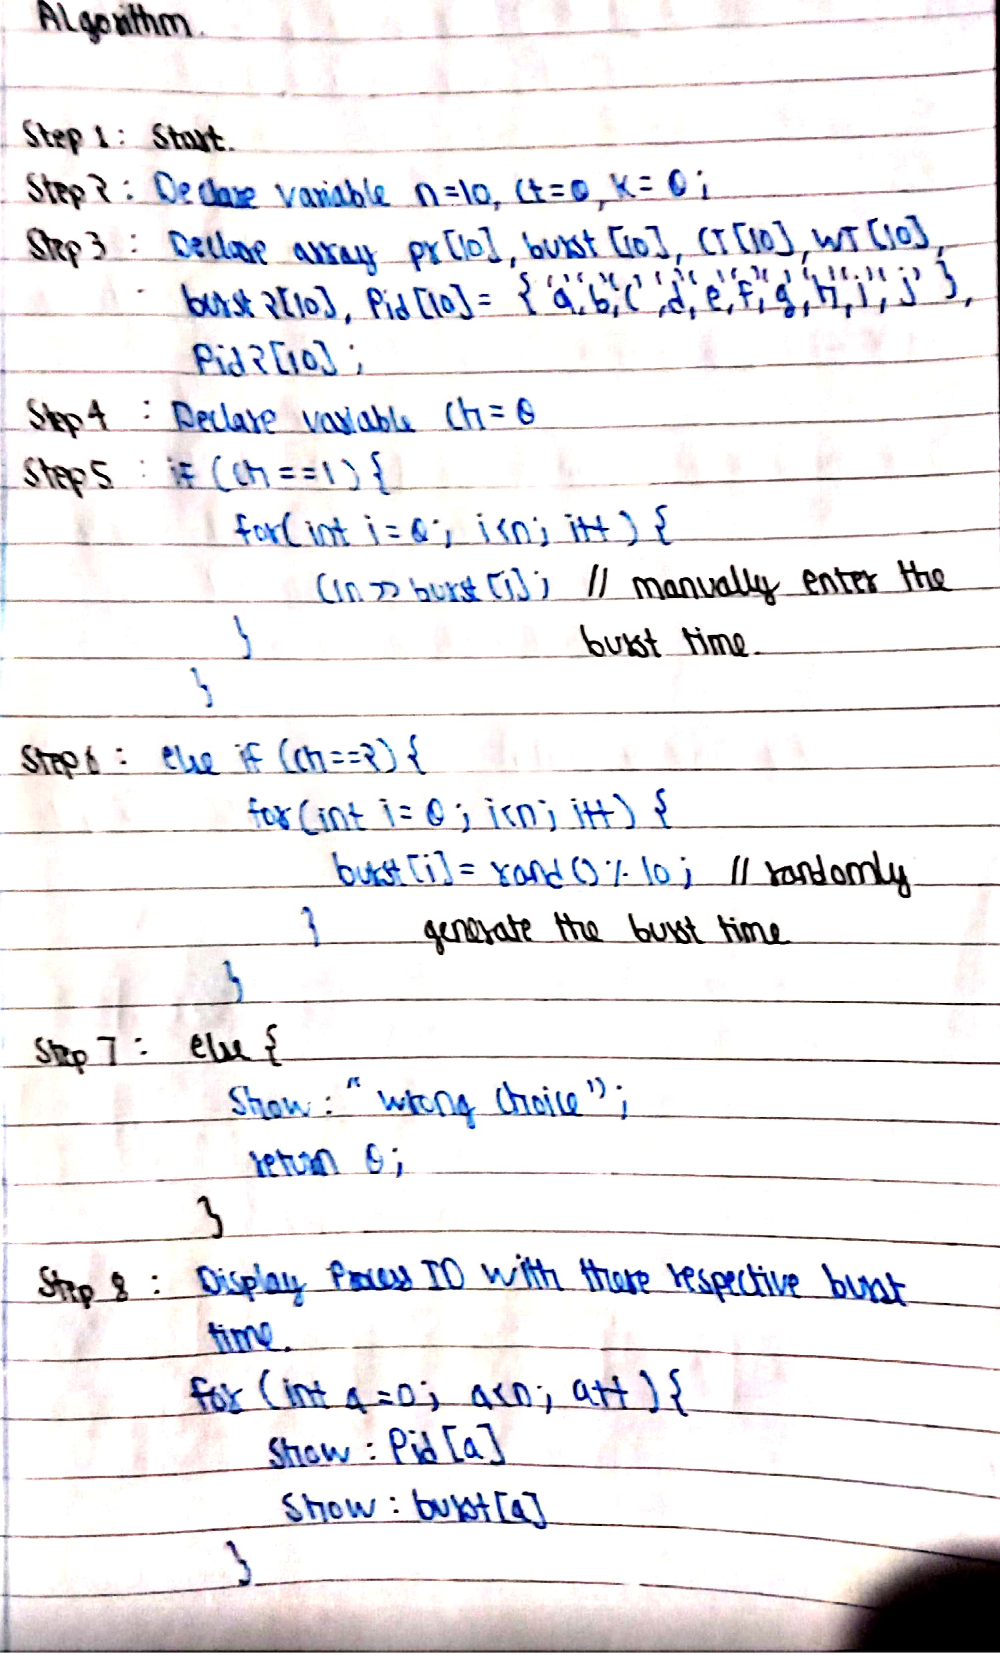
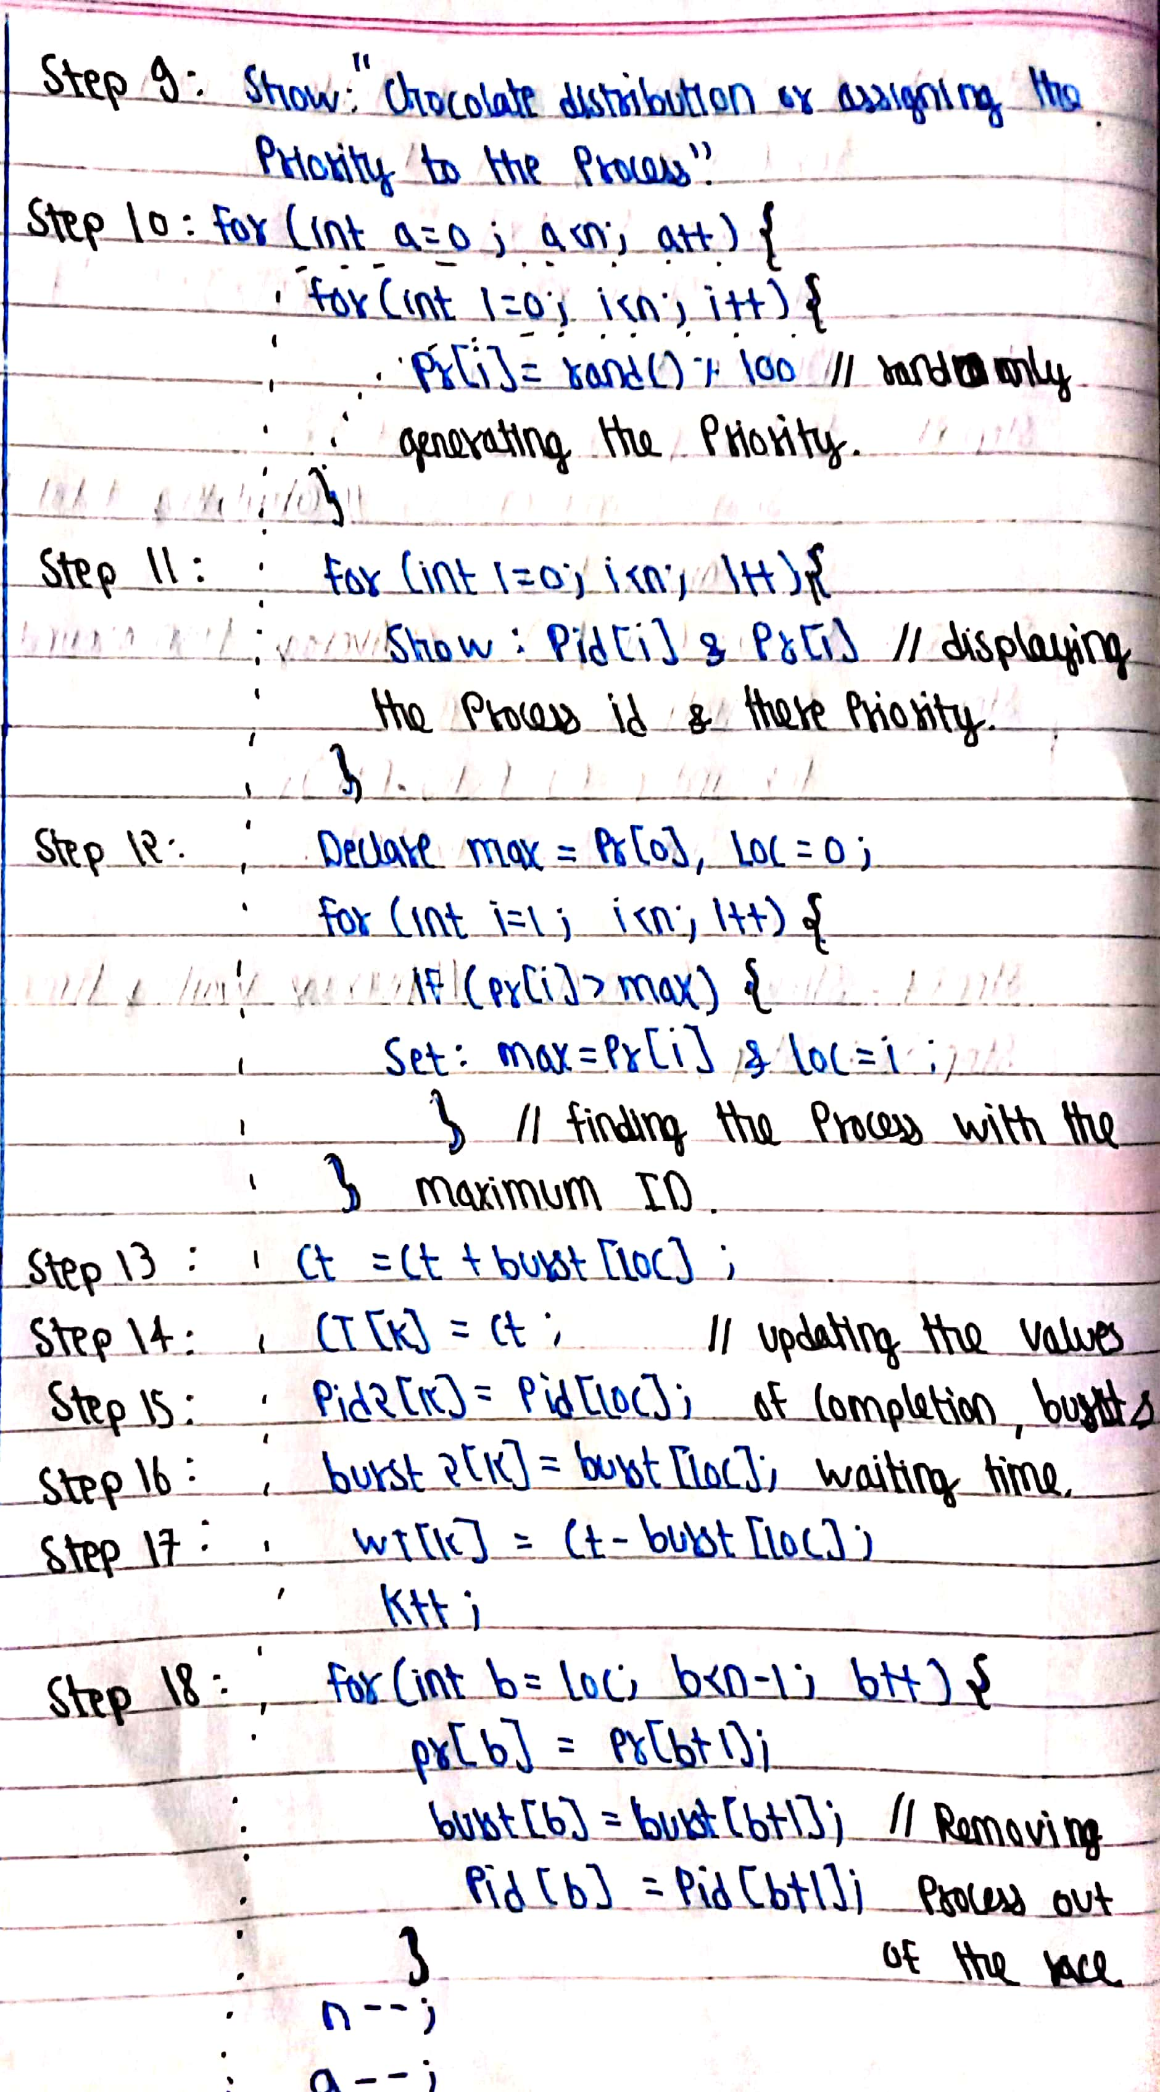
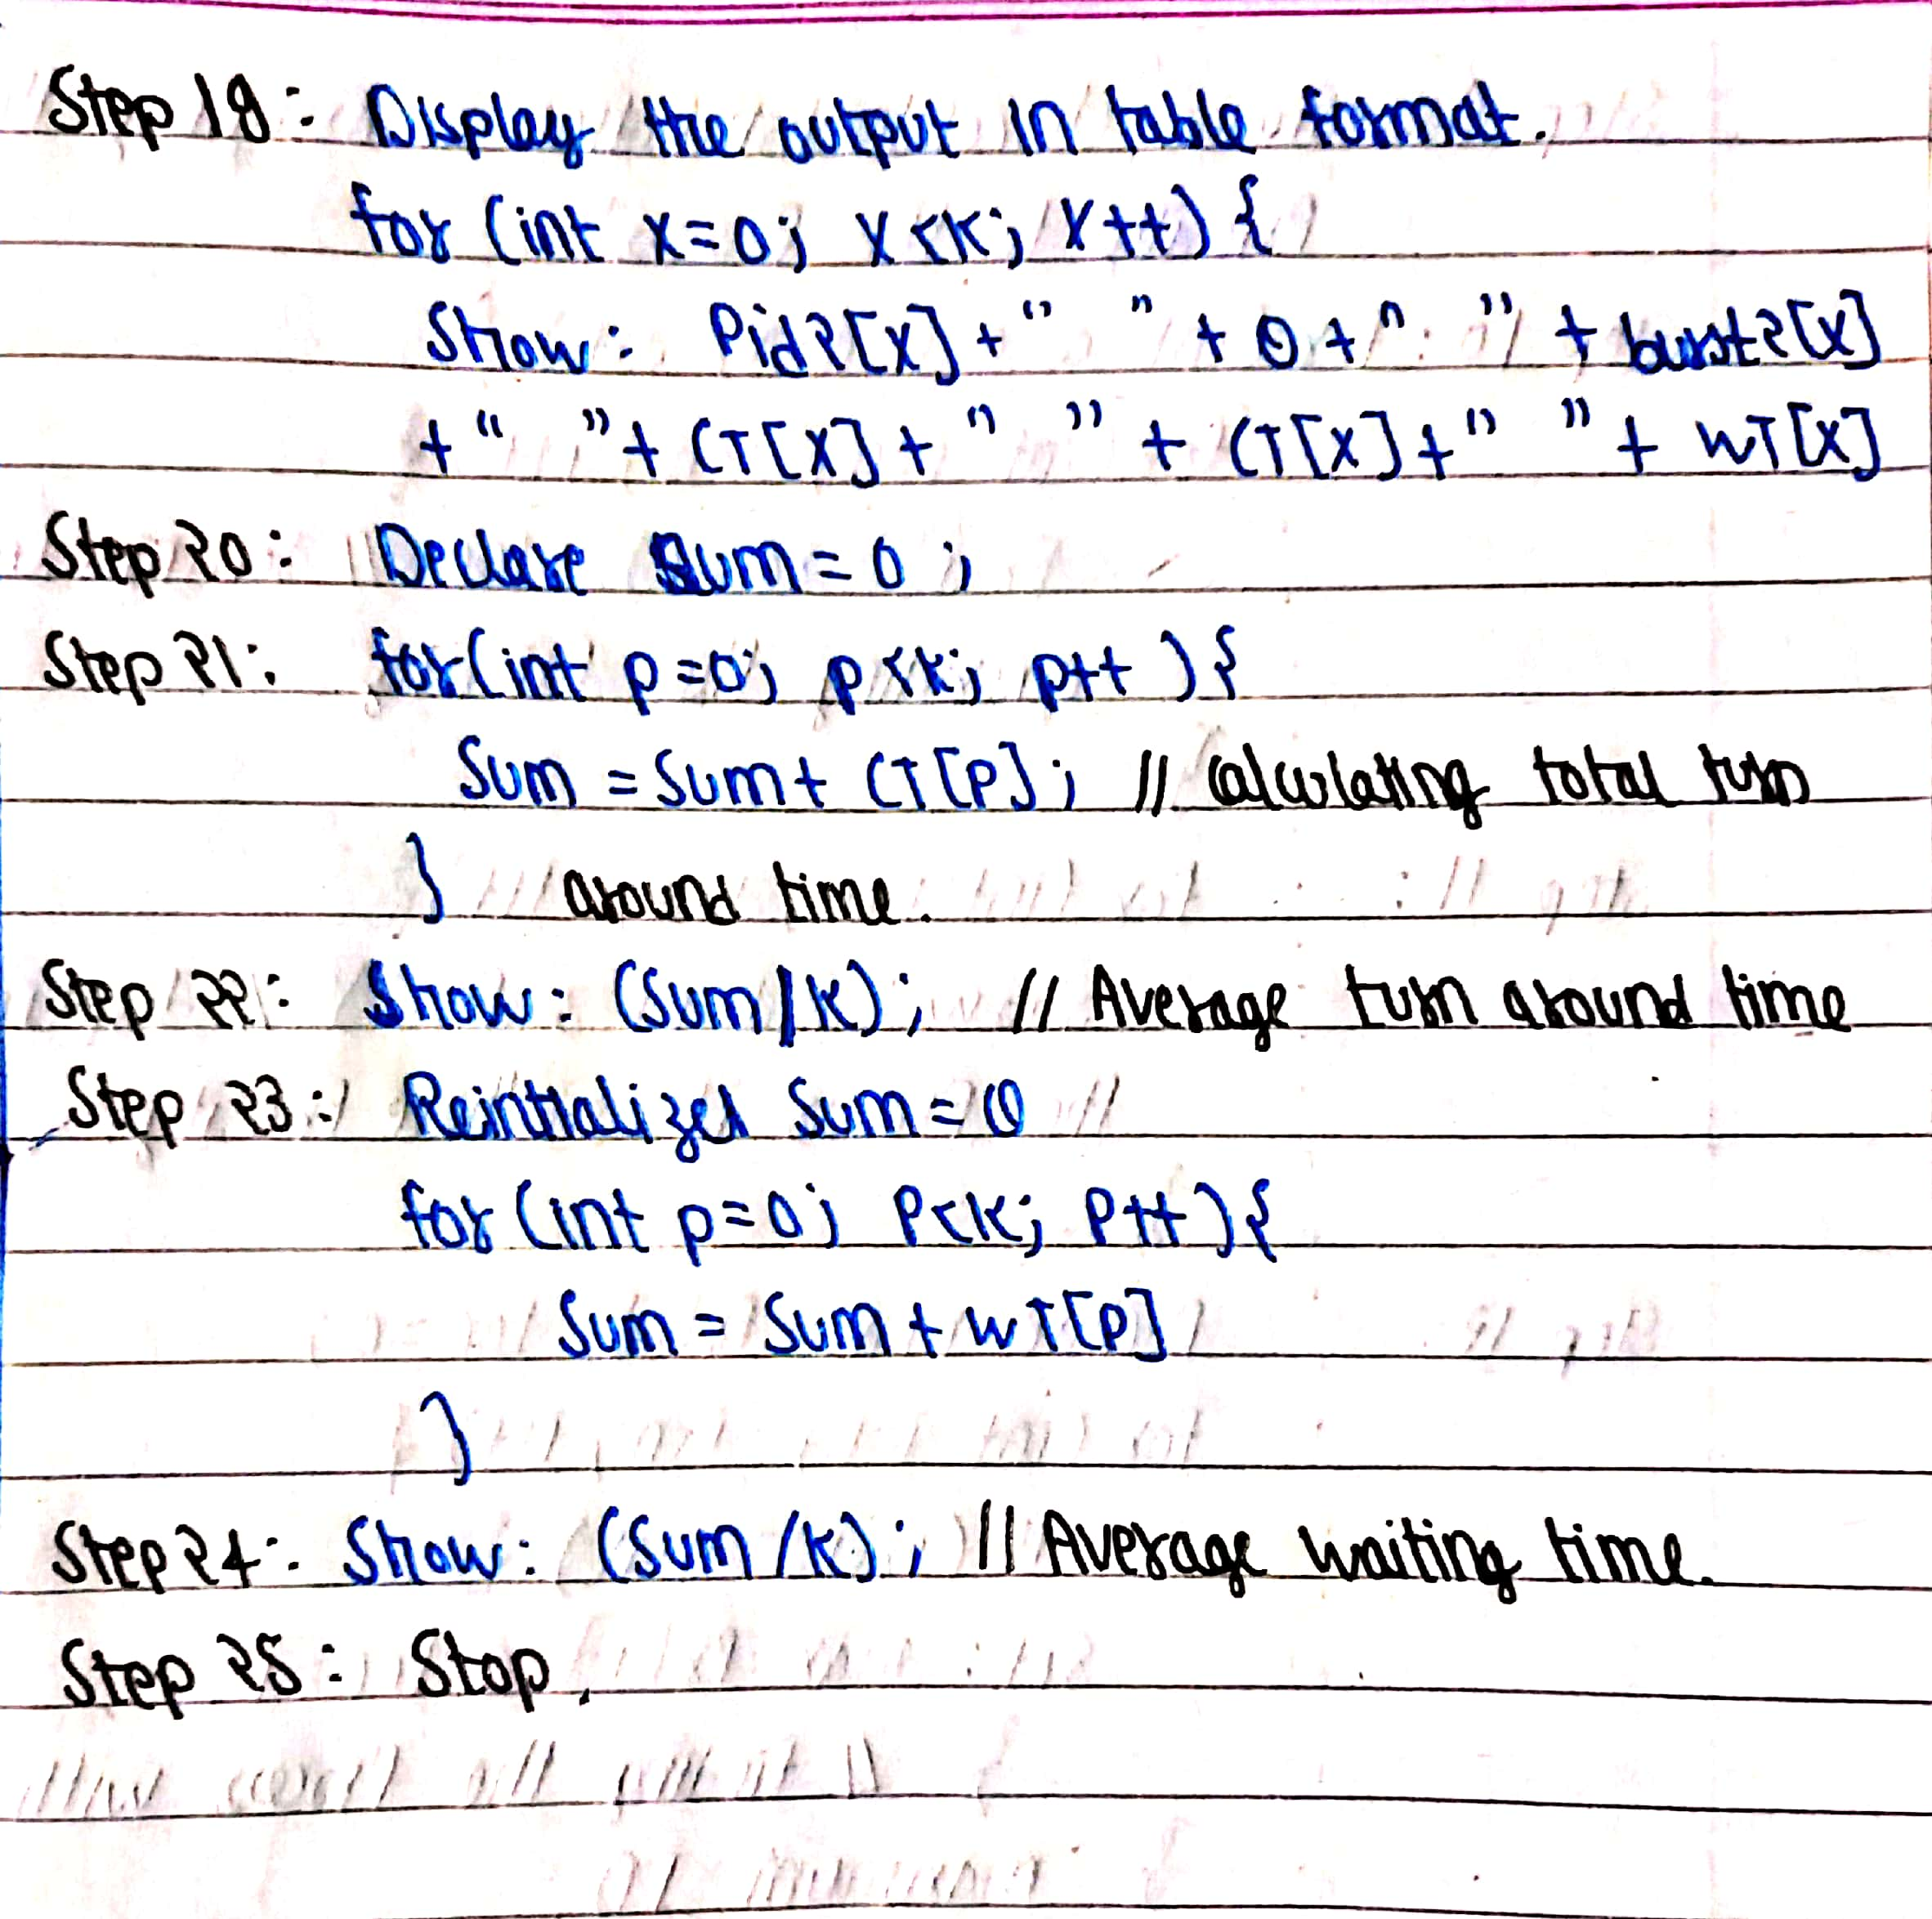
3.Calculate complexity of implemented algorithm.
- Overall Time complexity: O(n*2)
- Overall Space Complexity: O(n)

4.Explain all the constraints given in the problem. Attach the code snippet of the implemented constraint. Code snippet:
- The code implements the priority scheduling algorithm in which the priority of each process changes after each process gets the CPU.
- One of the constraints is that the code assumes that all the process arrives at the same time.
- There are two options to enter the burst time for each process. One is to enter the burst time manually and another is to genrates it randomly.
- For more explanation REFER Q7. Test cases
5.If you have implemented any additional algorithm to support the solution, explain the need and usage of the same. Description:
- No, I have not implemented any additional algorithm to support the solution.

6. Explain the boundary conditions of the implemented code. Description:
- Boundary condition for Arrival time: 0
The arrival time for all process is Zero, because we assume that all the processes arrive at the same time.
- Boundary condition for Burst time: 0 to +infinity
The value of burst time cannot be negative because its not possible, whereas the minimum value can be 0, and maximum value could anything greater than 0 as per the requirement of the process
- Boundary condition for priority: 0 to 99
The priority value of each process could be anything between 0 to 99 as it is randomly generated by rand() function.

7.Explain all the test cases applied on the solution of assigned problem. Description:
- Test case 1: When the Burst time for all the Process is Manually entered and all process arrives at the same time.
- Testcase 2: When the Burst time for all the process is randomly generated and all process arrives at the same time.
- In both the testcases the chocolate distribution or the priority assignment is done randomly.
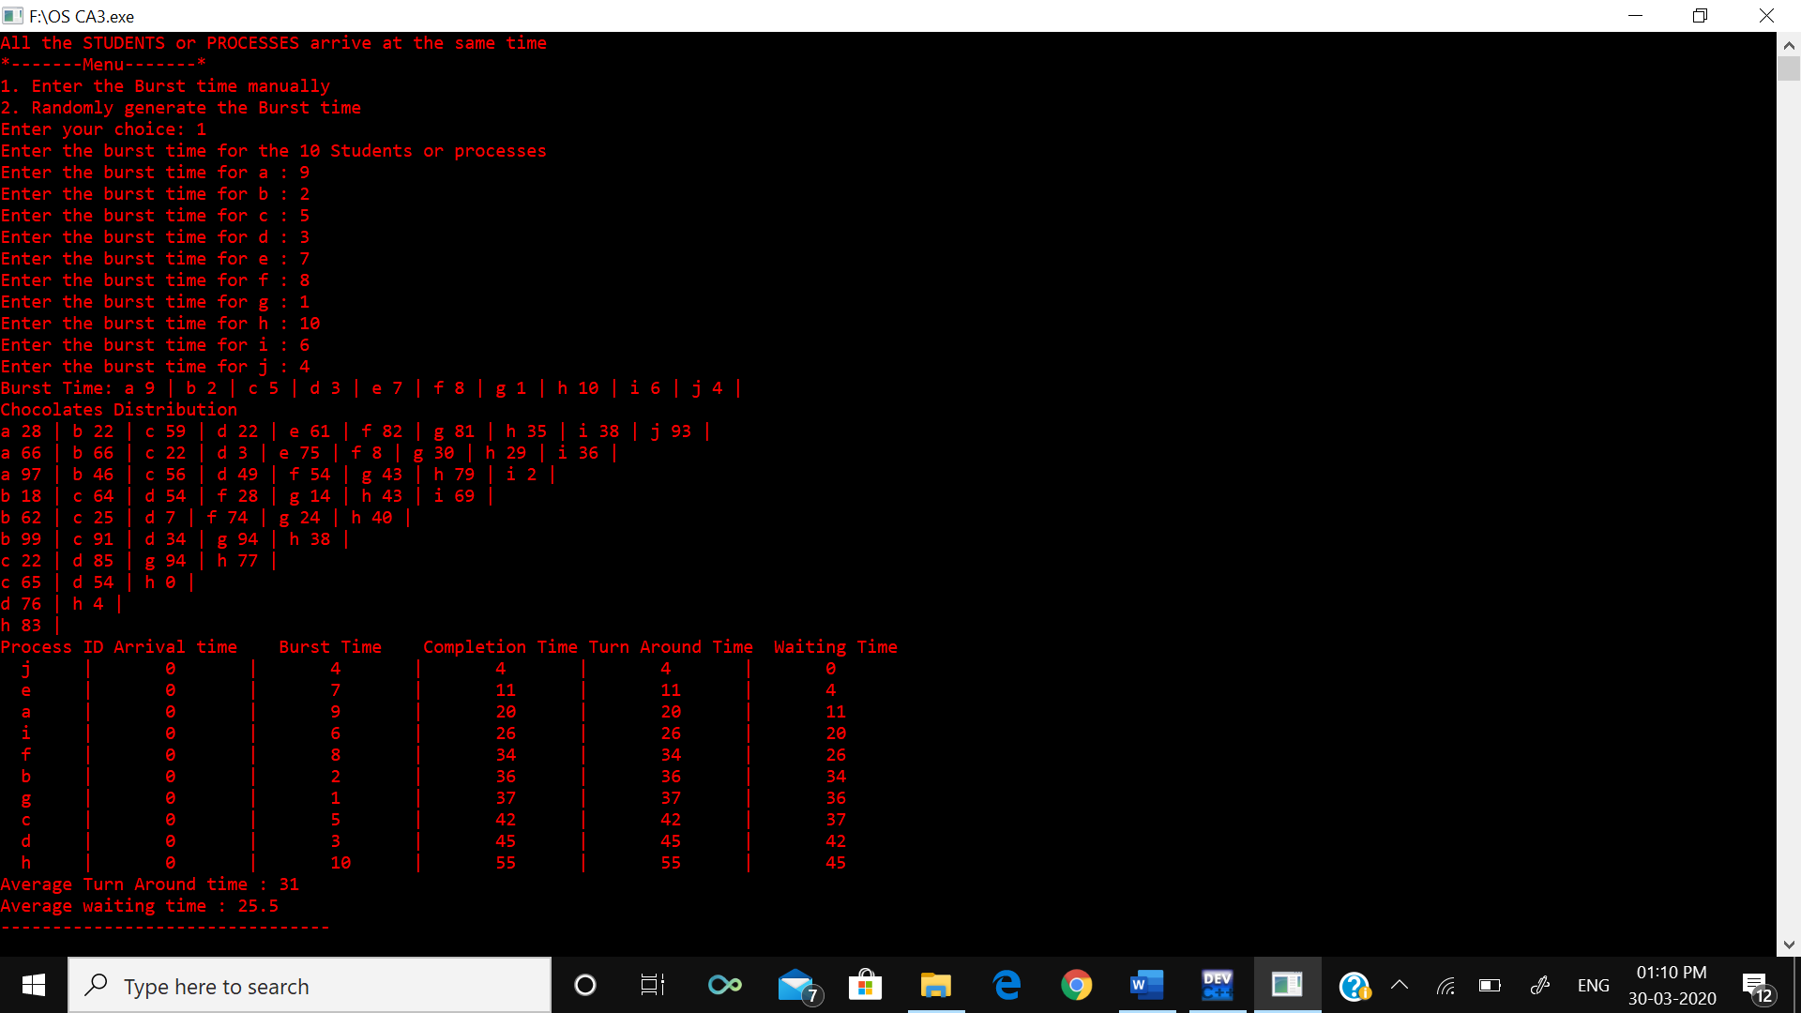
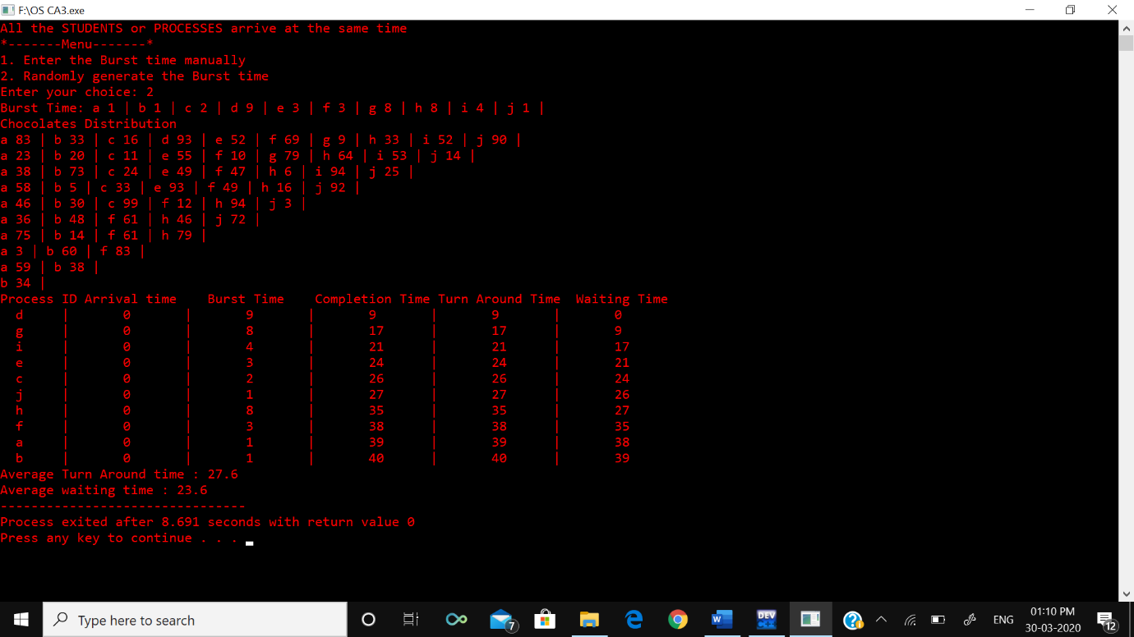

8.Have you made minimum 5 revisions of solution on GitHub? GitHub Link:
- Yes
https://github.com/vishalrana1305/OS-project

